Engaging 3PLs to Support the Public Health Supply Chain in Nigeria

Performance Management Plan

for Outsourcing the Distribution of Health Products
December 2023

This document is made possible by the generous support of the American people through the US Agency for International Development (USAID) contract no. 7200AA18C00074. The contents are the responsibility of Management Sciences for Health and do not necessarily reflect the views of USAID or the United States Government

About the USAID MTaPS Program
The USAID Medicines, Technologies, and Pharmaceutical Services (MTaPS) Program enables low- and middle-income countries to strengthen their pharmaceutical systems, which is pivotal to higher-performing health systems. MTaPS focuses on improving access to essential medical products and related services and on the appropriate use of medicines to ensure better health outcomes for all populations. The program brings expertise honed over decades of seminal pharmaceutical systems experience across more than 40 countries. The MTaPS approach builds sustainable gains in countries by including all actors in health care—government, civil society, the private sector, and academia. The program is implemented by a consortium of global and local partners and led by Management Sciences for Health (MSH), a global health nonprofit.
The MTaPS Consortium
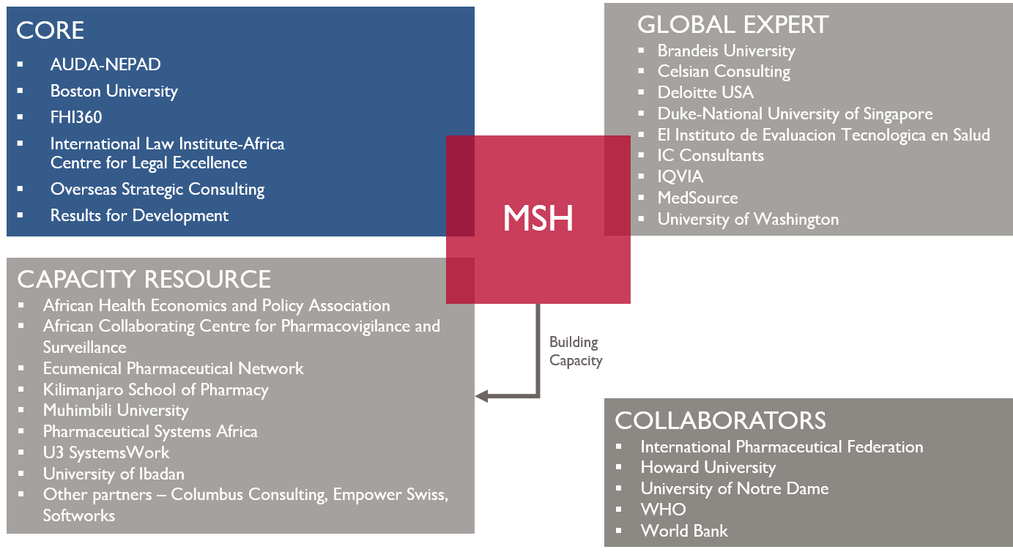

Acronyms and Abbreviations

3PL | third-party logistics provider
KPI | key performance indicator
LMD | last mile distribution
MOH | Ministry of Health
PPM | planned preventive maintenance
POC | point of contact
USAID | US Agency for International Development

Contents
Acronyms and Abbreviations i
Project Summary iii
1. INTRODUCTION 1
2. OBJECTIVES 1
3. PLAN STRUCTURE 1
3.1. THE STRATEGIC LEVEL 2
3.2. THE OPERATIONAL LEVEL 3
3.3. THE DEPARTMENTAL LEVEL 4
4. PERFORMANCE MEASURE DETAILS 5
5. ORGANIZATIONAL NEEDS FOR THE PERFORMANCE MANAGEMENT PLAN 6
6. PERFORMANCE ANALYSIS AND REVIEW MEETINGS 7
7. BASELINE STATISTICS AND PERFORMANCE TARGETS 8
8. ESCALATION APPROACHES AND THRESHOLDS 8
9. CONTINUOUS IMPROVEMENT INITIATIVES 9
10. CONCLUSION 9
Annex 1: Logistics provider scorecard 10
Annex 2: Baseline and target levels of performance 11
Annex 3: Daily operations report template 12

Project Summary
Program Name: |  | USAID Medicines, Technologies, and Pharmaceutical Services (MTaPS) Program
Activity Start Date and End Date: |  | September 20, 2018–September 19, 2024
Name of Prime Implementing Partner: |  | Management Sciences for Health
Contract Number: |  | 7200AA18C00074
MTaPS Partners | Core Partners | Boston University, FHI 360, Overseas Strategic Consulting, Results for Development, International Law Institute-Africa Centre for Legal Excellence, NEPAD
 | Global Expert Partners | Brandeis University, Deloitte USA, Duke-National University of Singapore, El Instituto de Evaluacion Technologica en Salud, IC Consultants, Imperial Health Sciences, MedSource, QuintilesIMS, University of Washington
 | Capacity Resource Partners | African Health Economics and Policy Association, Ecumenical Pharmaceutical Network, U3 SystemsWork, University of Ibadan, University of Ghana’s World Health Organizations (WHO) Pharmacovigilance Collaborating Center, Kilimanjaro School of Pharmacy, Muhimbili University, Pharmaceutical Systems Africa
 | Collaborators | International Pharmaceutical Federation, Howard University, University of Notre Dame, WHO, World Bank

- introduction
An important best practice for an outsourcing relationship between a public-sector agency and the logistics provider is a collaborative and ongoing review of the performance of the outsourced distribution services. The development and implementation of a performance management plan, once the contract has been signed, to assess the overall effectiveness of distribution activities, support the joint reporting processes, and measure the impact of any managerial interventions executed because of the joint review and reporting processes, is critical for success.
The agency has prepared this document regarding the last mile distribution (LMD) activity based on the Service Specification document that was developed and agreed with the potential service provider as part of the procurement process. The agency may find it necessary to implement additional measures to the ones articulated below, and further engagement may include continuous improvement activities to delve deeper into the root causes of performance-related issues.
- Objectives
Once LMD operations have commenced, the agency will implement a plan with the following objectives:
To suggest various performance measures for monitoring LMD performance in a range of operational areas
To propose an organizational structure that will enable both the agency and the chosen service provider to review performance achievement effectively
To advocate for continuous improvement utilizing baseline and target levels of improvement
To detail the suggested performance measures in terms of:
Calculation method
Organizational element responsible for producing the performance measure
Frequency of undertaking the calculation
Recipients of the results of the data gathering and analysis
- Plan structure
This plan is structured in the following manner and can be specified as needed.
Strategic level
Operational level
Departmental level
The three levels represent three tiers of management within both organizations (the agency and the chosen service provider). Most senior managers will be presented with a few strategic measures relating to top-level cost and customer satisfaction data. The operational level consists of the agency’s Contract Manager and the Operations Manager of the selected service provider. These measures are aimed at assessing the value for money being provided by the selected service provider. At the lowest departmental level, more measures are deployed to provide technical managers with greater detail on daily or weekly operational performance. They are aimed at capturing information to support any immediate operational interventions that may be required. These measures may also provide insight into recurring performance issues or trends for future operational planning. This three-tiered structure illustrates the various levels of performance management and is intended to improve efficiency in decision making.
Considerations for each level include:
Specified performance measures with agreed-upon calculations
A limited number of performance measures in order to avoid complexity, maintain clarity, and ensure accountability
The frequency at which performance measures will be produced and reviewed by the management teams of both organizations
The entity responsible for producing and circulating the performance measures
The recipients of the information
Both baseline and target levels of performance
Certain performance measures can be used at Monthly and/or Quarterly Review Meetings by the respective teams to facilitate management decisions. These measures can be tracked over time and used as evidence for interventions that support the achievement of both short- and medium-term performance targets and continuous improvement goals. Daily and weekly reports specified in the Service Specification document may not necessarily be reviewed at management meetings; however, senior managers may request more granular data.
Strategic-level performance measures and key performance indicators (KPIs) provide an overall view of the performance of the function without necessarily providing insights into the reasons for achieving the level of performance. The measures at the operational and departmental levels highlight aspects of the activity and provide insight into the achievement at the strategic level. Furthermore, although the overall performance of the distribution activities can be obtained at the strategic level, individual functional managers, within the agency and third-party logistics service providers (3PL), can only be held accountable for those elements and functions of the activity for which they have responsibility. For example, the Vehicle Maintenance Supervisor can be held responsible for the level of adherence to planned service intervals, but not for the level of in-transit damage. This latter measurement may be the responsibility of the Dispatch Supervisor, as he or she would supervise vehicle loading and the deployment of load-restraining equipment.
  - THE STRATEGIC LEVEL
As distribution activities are only there to support the Ministry of Health (MOH) in achieving its mission and vision, the nature of the plan at this point aims to provide an overall view of the effectiveness of the activity. The monitoring process is designed to provide a view of the cost and service balance for senior managers within the MOH, the agency, and the selected service providers. Typical indicators include:
The level of customer satisfaction can be assessed through an analysis of the complaints process and a biannual questionnaire. The customers, in this case, the health care professionals at the various health facilities, should be surveyed to understand their opinions regarding the level of service that they receive from the agency and the chosen service provider. (Given the data collection requirements for this KPI, this process could be used to develop and maintain customer relationships or identify areas of improvement.)
An overall view of the on-time delivery performance level for deliveries to health facilities. “On-time delivery” will be explicitly defined to avoid miscommunication or confusion regarding what is considered to be “on time.” (Although the overall supply chain performance measure combines timeliness and completeness [in full], the distribution activity only has very limited impact on the in-full element of the overall strategic supply chain measure.) A more granular (actionable and operational) view can be obtained by monitoring the on-time percentage at the various health centers.
The level of conformance to budgeted expenditure. Both actual and planned costs can be provided with relation to volume and cost variances.
This top-level information, produced quarterly, provides senior managers with an overall view of the cost and service balance being achieved by the outsourcing operation and can direct further improvement activities.
  - THE OPERATIONAL LEVEL
Although the information produced at the strategic level provides a top-level view of the distribution function’s performance, it is important to understand the performance level of the individual elements of the operation. Operational level performance measures assess which of the individual elements of operation are performing as planned and which of them are underperforming and potentially impacting the performance of the others. Typical measures include:
On-time deliveries for different types of health facility or by local government areas or by ward. This measure provides a more granular analysis of the strategic KPI based on what categorization and grouping has been agreed upon to be monitored individually.
In-transit product loss and damage
Temperature control failures
Overall schedule compliance in terms of total trip time
An analysis of the reasons for proxy deliveries
The focus at this level is to measure if the 3PL is delivering value for money, i.e., if the strategic objectives are being achieved inefficiently as a result of over-resourcing the activity or not. The statistics should be produced monthly by the 3PL’s team and circulated in advance of a monthly review meeting attended by the agency’s Contract Manager and the 3PL’s Head of Operations. These two executives may also attend the reviews held quarterly.
  - THE DEPARTMENTAL LEVEL
Each individual distribution function will require ongoing data collection to support interventions and improve the performance of that function. In many instances, the data gathered at this level will be needed when management investigates the root causes of the shortcomings at the strategic and operational levels.
The agency may find it necessary to introduce performance measures for limited periods of time to monitor the effectiveness of managerial interventions to improve recently occurring issues. Similarly, the gathering of specific information can be ceased once an issue has been addressed. Operational issues highlighted during the performance monitoring process may be alleviated by the introduction of a new process with supporting standard operating procedures, which should appropriately direct data gathering efforts related to the issue.
Typical measures include:
The level of vehicle downtime with an analysis of the reasons for vehicle non-availability
Truck on time availability
The level of routes experiencing issues, such as delays and non-conformance to schedule
The level of subcontracting and the reasons behind the need to do so
The extent to which planned preventive maintenance (PPM) is undertaken as planned
The number of vehicles rejected by quality managers at the time of loading
The Performance Management Plan Pyramid presented below summarizes the overall plan and specific measures at the various levels of the plan.
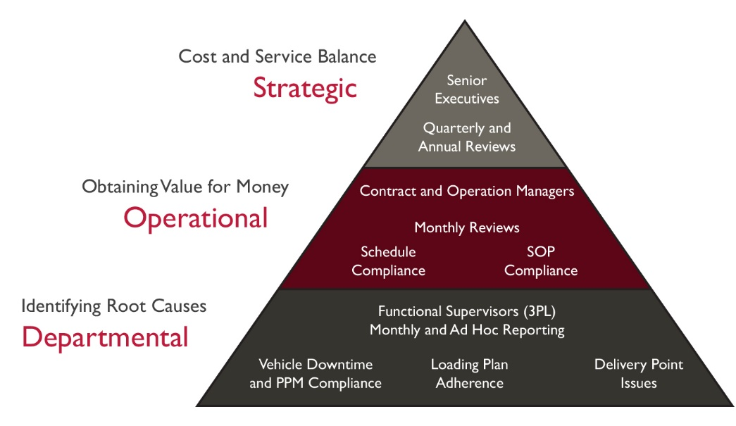
Figure 1. Performance Management Plan Pyramid

- Performance measure details
The following tables provide more details regarding the calculation of performance measures and their subsequent use by the management and operational teams of both organizations.
Table 1. Strategic level: performance measures/KPIs
Performance Measure/KPI | Calculation/Information Gathering Technique | Production Frequency | Production Responsibility | Recipients
Level of customer satisfaction at health facility level* | Customer Survey Questionnaire (ideally collected electronically; see suggested template in Annex 1) | Six-monthly | MOH and public-sector agency | A wide distribution across the public health care community**
On-time delivery (%)*** | (Number of on-time deliveries/Total deliveries executed) x 100 | Quarterly | 3PL dispatch team | Senior MOH and 3PL executives
Compliance to budgeted costs (%) | (Actual costs/Budgeted costs) x 100  Cost and volume variances | Quarterly | 3PL, MOH and agency finance teams | Senior MOH and 3PL executives

*It would help to have a standard approach to gathering survey information. This might mean defining how many customers are sent the survey, the required number or percentage of responses in order to obtain representative feedback, and the process for analyzing and taking action to address responses.
**In the event that there are only a few hospitals, it would ideally mean surveying them all. However, if there are a large number of small clinics—say around 500—it might need a survey of 20% with the aim of getting a 10–15% response. In terms of analysis, it depends on the type of survey used. An email version of the template presented in Annex 1: Logistics Provider Scorecard could be handled by a manual spreadsheet on receipt of the templates from the surveyed locations. Alternatively, a telephone survey would gather the data as and when the calls are made. Regardless of the technique deployed, the responses will be addressed by the various levels of management at the monthly and quarterly meetings.
***It is important to define what on-time delivery means, as there could be a range of variances in terms of days or hours. It may also be useful to gather data on how late the deliveries are, since longer delays, such as of a week or more, may have more pronounced negative consequences than delays of one day. Once the overall level of lateness has been obtained, it is important to establish the extent of the lateness compared with the defined standards/targets. This is done by analyzing the number of days taken to execute all the deliveries to each type of health facility for a range of lateness, for example, 1 to 5 days, 5 to 10 days, and in excess of 10 days.
Table 2. Operational level: performance measures/KPIs
Performance Measure/KPI | Calculation/Information Gathering Technique | Production Frequency | Production Responsibility | Recipients
On-time deliveries by health care facility type (%) | For each facility type (Number of on-time deliveries/total number of deliveries) x 100 | Monthly | 3PL dispatch team | Agency Contract Manager and 3PL Operations Manager
In-transit product loss and damage (%) | (Value of goods lost or damaged in-transit/Total value of goods dispatched) x 100 | Monthly | MOH finance team and 3PL dispatch team | Agency Contract Manager and 3PL Operations Manager
Temperature control failures (%) | (Number of temperature control failures/Total number of temperature-controlled dispatches) x 100 | Monthly | Agency Quality Assurance Supervisor | Agency Contract Manager and 3PL Operations Manager
Schedule compliance (%) | (Number of routes completed on time/Total number of routes executed) x 100 | Monthly | 3PL dispatch team | Agency Contract Manager and 3PL Operations Manager
Proxy deliveries by reason | Total proxy deliveries analyzed by reason category | Monthly | 3PL dispatch team | Agency Contract Manager and 3PL Operations Manager
Table 3. Departmental level: performance measures/KPIs
Performance Measure/KPI | Calculation/Information Gathering Technique | Production Frequency | Production Responsibility | Recipients**
The level of vehicle downtime (%) | (Number of vehicle days “lost”/Total vehicle days) x 100  Analyzed by vehicle category | Monthly | 3PL dispatch team and maintenance supervisor | Operations teams of 3PL and the agency
Truck availability (%) | (Number of trucks arriving late for loading/Total trucks loading) x 100 | Monthly | Agency warehouse supervisor | Operations teams
The level of routes experiencing issues (%)* | (Number of routes with schedule issues/Number of routes dispatched) x 100 | Monthly | 3PL dispatch team (debrief supervisor) | Operations teams of 3PL and the agency
The level of sub-contracting (%) | (Number of routes executed by subcontractors/Total routes dispatched) x 100 | Monthly | 3PL dispatch team (pre-loading vehicle inspector) | Operations teams of 3PL and the agency
PPM schedule compliance (%) | Number of vehicles maintained as planned/Total number of PPM activities) x 100 | Monthly | 3PL maintenance supervisor | Operations teams of 3PL and the agency
Level of rejected vehicles pre-loading (%) | (Number of vehicles rejected pre-loading/Total number of vehicles loaded) x 100 | Monthly | Agency quality supervisor plus reason analysis | Operations teams of 3PL and the agency

* Issues of delays may be due to reasons such as the unavailability of an authorized recipient; poor road conditions and/or road work, roadblocks, and accidents; inaccurate delivery addresses; lack of secure overnight facilities; and limited fuel depots, to name a few.
** Recipients could be senior executives, Contract Manager, and Operations Manager as required.
Although the relationship requires trust between the two organizations, the agency team can undertake spot checks to validate the data being produced, particularly if concerns are raised regarding the accuracy of the presented information.
The above tables indicate the type of data required: the element of the organization responsible for obtaining the data and undertaking the calculations, and the recipients of the results. Data may come from a range of sources, so it would behoove the agency team to develop a standardized format for presenting information. If the data are not available electronically, the sources of the information may include warehouse security office records, warehouse dispatch and delivery documents, loading plan records, driver log sheets, and supervisor debrief forms. The corresponding data source shall be identified and applied to guide the collection of data for the respective performance measure.
- Organizational needs for the performance management plan
For the successful monitoring and evaluation of the distribution activities and execution of the performance management plan, the agency will develop an organizational structure to reflect the various levels of the plan. Nominated members of the current staff will be points of contact (POC), as detailed in the Best Practice Guidance Document (2023), to collaborate with specific members of the 3PL’s management team. Figure 2 presents the reporting and communication structure needed to implement the performance management plan effectively.
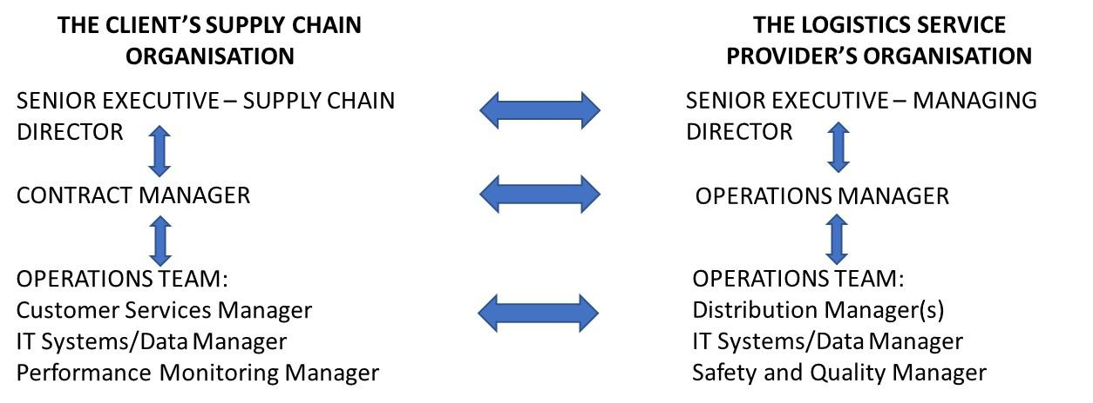
Figure 2. Best practice organizational relationships
At each level of reporting, there shall be identified POCs in both organizations that communicate with each other. They are likely to communicate with other members of staff in their own organization; however, they should only communicate with their nominated contact in the other organization. It is important that discipline is maintained to ensure that reliable and consistent communication and reporting takes place.
- Performance analysis and review meetings
Once performance data are collected, measures are calculated and circulated on a quarterly or monthly basis; they need to be reviewed by the designated managers at each level of the plan structure. The review meeting agendas may contain more topics than performance monitoring, but the key activity is the reviewing of performance monitoring and making decisions, as necessary, aimed at improving performance levels. Meetings may focus on specific indicators, monthly trends, etc., based on visual alerts communicated after data analysis. Meetings can be structured to fit the needs of strategic initiatives, communication facilitation between stakeholders, or performance issues spanning multiple processes or parties.
In addition to putting in place the appropriate organizational relationships, the monthly and quarterly meeting dates need to be confirmed well in advance to ensure that the planned meetings take place on a regular basis. Confirmed meeting dates will facilitate the production and pre-circulation of the performance measures.
It is expected that the service provider will collect the data from their own operational systems, either manually or (preferably) electronically, and produce the performance measures for circulation in advance of the review meetings. All meetings should have concise action point notes for circulation as required to other members of the review team.
Best practices include categorical reviews of 3PLs in relation to their contract status and performance for logistics provision. For example, the focus of the review meetings with 3PLs that are new would likely require a different monitoring approach than 3PLs that have had historically good performance or 3PLs that are being grown and developed to take on additional work or mature certain processes. Another category could also be 3PLs whose contracts are planned to be terminated or currently in “exit” mode. Lastly, 3PLs that are underperforming, have escalations, or require regular attention would benefit from dedicated problem-solving sessions so that they do not overshadow routine or non-urgent performance monitoring.
Best practice relationships tend to involve contracts of at least three years. Contracts will have incorporated termination clauses from a legal perspective. For a successful implementation of the contract, to ensure a good long-term working relationship, effective quarterly and annual review meetings are essential. However, by agreement, the review frequencies can be revised to reflect operational performance and confidence between the parties. For example, after one year of excellent performance, the review meetings involving the senior executives could be lengthened to six months. However, should circumstances change, quarterly intervals could become bimonthly until performance levels improve, or regrettably, the contract termination clause needs to be executed.
In addition, the agency will require a daily operations report to be circulated at an agreed-upon time each day, to provide management with the status of the operation at that moment in time, and more importantly, a brief of any planned actions to resolve immediate operational issues. Annex 3 (Daily Operations Report Template) provides an outline for the completion of the report. Once the two organizations have been working together satisfactorily for some months, the agency and the service provider might consider a weekly, rather than a daily, report. If so, there will be a need for the two organizations to agree on the format of the brief document.
- Baseline statistics and performance targets
In order to assess the level of improvement being achieved and set improvement target levels, an understanding of the current level of performance, the baseline level is needed, by both of the organizations, at the outset of the plan. In the event that those statistics are not available, the performance levels achieved in the first few months of operating the plan can be categorized as baseline statistics. It is important to target a steady increase in performance over a reasonable period of time. The agency and the service provider should avoid unrealistic targets, in terms of both performance and time scale, as they are likely to result in a breakdown of the relationship between them and tend to demotivate, rather than motivate, everybody involved.
Annex 2 (Baseline and Target Levels of Performance) presents the current position for each of the KPIs and performance measures detailed above. This table should be populated with respective baseline and target performance levels after discussions between the two organizations.
- Escalation approaches and thresholds
As each level of management conducts a performance review, issues that arise will require different levels of attention. The contracted 3PL service provider is expected to perform well, meeting targets and solving issues with little support from the agency team. In order to determine the level of engagement that the logistics service provider requires of functional supervisors and operations managers, there should be an established threshold or minimum standard of performance. This includes creating a ranking or rating mechanism for each indicator. For example, a stoplight system for on-time delivery would show green if the indicator is equal to or above 93%, yellow if the indicator is between 85% and 93%, and red if the indicator is equal to or below 85%. Performances that are found to be low are then escalated to the next level of management for further discussion and resolution. Another approach to escalation may be linked to the number of incidences impacting delivery over time or the recurrence of issues despite mitigative actions. A log of indicators for the 3PL provider would enable trends to be monitored on a weekly, monthly, or quarterly basis in order to allow both strategic and operational decisions to be data driven. The extent to which this level of detail is required and how regularly indicators are monitored may be determined by the magnitude and/or frequency of escalations to the next level of management. Certain indicators may also be closely monitored during organizational or process changes, seasonal labor migration, weather-related restrictions, emergent health care needs, regulatory changes, or even initiatives intended to improve performance.
- Continuous improvement initiatives
As indicated above, performance review meetings should include status updates on improvement activities, trend analysis, and next steps and actions to improve underperformance. As performance review meetings would be conducted at various levels, these escalations would be complemented by mitigation plans, clear roles and responsibilities among stakeholders, defined actions, and timeliness of implementation.
The 3PL organization and the agency, jointly, should identify areas for continuous enhancement, based on the performance measure analysis, trends, root cause analysis (as needed), and agreed-upon mitigation actions from the review meetings, and implement action plans to address them. This could involve process optimization, technology upgrades, or staff training from both sides.
Continuous improvement is an ongoing process that requires commitment, collaboration, and a willingness to adapt and evolve based on changing circumstances and opportunities.
- Conclusion
An effective performance management plan is essential to assess the overall effectiveness of the distribution activities, support the reporting processes and measure the impact of any managerial interventions. The agency plan has three distinct levels, namely, strategic, operational, and departmental. Each level has its own specific performance measures with baseline data and target levels of performance, the provider of the information, the frequency of review and the various levels of management undertaking those reviews.
The three levels focus upon different aspects of the activity providing the different views required by the managers at those levels of the activity. The strategic level considers crucial supply chain focus, cost, and service balance. The operational level assesses the value for money being achieved by the operation as a whole. The departmental level presents more detailed information underlying the reasons for the levels of performance achieved at the strategic and operational levels.
For the successful implementation of the plan, an appropriate organization structure needs to be introduced by both organizations to facilitate effective reporting and communication relationships.

Annex 1: Logistics provider scorecard
This is a suggested template for receiving feedback from individual health facilities to collect data for the first strategic-level indicator, “Level of customer satisfaction.” This template can be sent to health facilities as an electronic or a hard copy to collect information.
The specific notes column below should be used to record any additional points that support the scores given for each aspect of service. The general remarks section should be used to focus more on the low-scoring components and on what needs to be done to improve performance.
Basic Information |  |  |  | Date:
Organization  Name |  |  |  | Organization  Type / ID
Logistics  Provider |  |  |  | Review  Period
Evaluation
 | 1.  Poor | 2.  Fair | 3.  Satisfactory |  | 4.  Good | 5.  Excellent | N/A | Specific Notes
Communication

Quality of service

On-time delivery

Staff interaction

Continuous improvement

Adaptability for unexpected deliveries

Report
General Remarks

This section should focus
more on the critical issues
(i.e., scores of less than 3)
and include recommendations
on what needs to be improved.

Annex 2. Baseline and target levels of performance
KPI/Performance Measure | Baseline | Target 6 months | Target 12 months
Level of customer satisfaction

On-time delivery (%)

Compliance to budgeted costs (%)

On-time deliveries by health care facility type (%)

In-transit product loss and damage (%)

Temperature-control failures (%)

Schedule compliance (%)

Proxy deliveries by reason

The level of vehicle downtime (%)

Truck on-time availability (%)

The level of routes experiencing issues (%)

The level of sub-contracting (%)

PPM schedule compliance (%)

Level of rejected vehicles pre-loading (%)

Loading schedule compliance (%)

Annex 3: Daily operations report template

Name of third-party logistics service provider:
Loading location:
Date and time of completion of this report:
Number of outgoing loads scheduled to have departed yesterday:
Number of outgoing loads scheduled to have departed not yet loaded:
Proposed actions to load and dispatch late departure:

Next 24 hours, concerns, and planned interventions:

Completed by:

